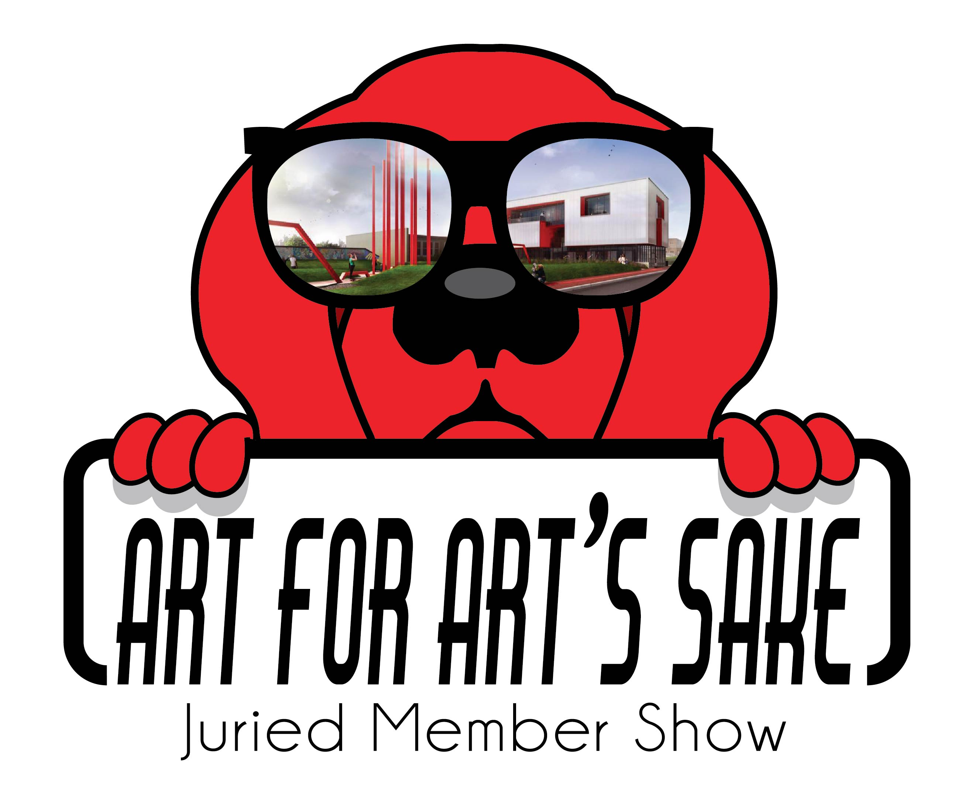
RED DOG GALLERY PRESENTS
BLOOM
A Juried Exhibition Celebrating New Beginnings, a Flowering of Self, Rising to the Occasion or Simply the Flowers of Spring.
Sponsored by Art for Art’s Sake

CALL FOR ART

This is a call for all AFAS artists to submit your latest work for BLOOM. This exhibition is an opportunity to embrace the idea of change, personal growth, flowering of the spirit, rising to the occasion, a coming out or reaching for the stars. Up to three submissions per artist will be juried for this show. We encourage two and three-dimensional art in all mediums. Smaller art pieces are especially encouraged with a consideration to price point and size. The reception for Bloom will be held on Friday, May 4, 2018 from 7 to 10 pm. The exhibit will run May 4 to Sat. June 30. We encourage all AFAS artists to share this event with friends on Facebook, Twitter and Email. All artwork to be submitted digitally at www.theafasgroup.com. click on Red Dog Gallery, Submissions and follow prompts. Complete steps for submission and prospectus follow:

Eligibility/Requirements
Eligibility: The exhibition is open to all AFAS artists.
Entry Deadline: Sat., April 21, 2018
Art Drop-Off: Fri., April 27, 2018 (12 pm to 6 pm); Sat., April 28 (11am to 4 pm)
Reception: Friday, May 4, 2018 (7 to 10 pm)
Pick up: Sat., June 30, 2018 (11 am to 4 pm)

Entries: Up to 3 pieces of original artwork may be submitted on the Entry Form. Not all accepted art pieces may be exhibited at once, but hung at a designated time during the show’s duration.

All artwork submitted must be for sale.
No erotic art will be accepted for this exhibit.

Eligible Work:

This AFAS exhibition is to showcase outstanding visual art in two and three-dimensional art media. All 2-D and 3-D work must be “exhibition ready” upon delivery. PLEASE READ CAREFULLY WHAT EXHIBITION READY REQUIRES:

Size limitations:
- 2-D artwork – maximum size 48” x 60”
- 3-D artwork must be able to fit through a standard door and be no taller than 7 feet tall and 4 feet wide.
- 3-D artwork may weigh no more than 200 lbs.

2-D artwork must be framed and securely wired or on securely wired stretched canvas, finished on all sides. No clip mounting or saw tooth hangers will be accepted. If not adequately prepared for display, artwork will be withdrawn from the exhibition. The AFAS Group reserves the right to refuse any submission that it deems unacceptable.

Digital Submission:
Go to AFAS at www.theafasgroup.com
Click on RED DOG Gallery (at top of page)
Click on Submissions
Follow the prompts

Note: Images submitted for approval should not include the artist, as submissions are anonymous.

Be sure to submit Entry Form, Inventory Sheet, Bio and Digital Images of your artwork.

Digital Images:
ALL DIGITAL IMAGES MUST BE .JPG OR PNG FORMAT AND AT LEAST 72 DPI AND NOT MORE THAN 2MB IN SIZE.

Commission: All work available will have a commission of 35% attached as required by the AFAS Group.

ARTISTS’ CHECK LIST:
DEADLINE: Sat., April 21, 2018
ENTRY FORM, INVENTORY SHEET, BIO, IMAGES
DROP OFF: Fri., April 27 (12 am to 6 pm); Sat., April 28 (11 am to 4 pm)
PLEASE TAPE LABELS TO BACK OF WORK, SIGN EXHIBITION CONTRACT
RECEPTION: FRIDAY, May 4 (7 TO 10 PM) Artists attendance at this event is encouraged
PICK UP: Sat., June 30 (11 am to 4 pm)

DELIVERY/STORAGE OF ACCEPTED ART

ALL WORK SHOULD BE DELIVERED TO:
RED DOD GALLERY
630 N. LIBERTY STREET
WINSTON SALEM, NC
27101

PLEASE DELIVER AND PICK UP WORK DURING THE DESIGNATED TIMES. LATE WORK WILL NOT BE ACCEPTED. WORKS LEFT FOR MORE THAN 30 DAYS AFTER THE PICK-UP DATE BECOME THE PROPERTY OF AFAS. IF YOU HAVE SPECIAL CIRCUMSTANCES REGARDING ART DELIVERY/DROP OFF AND PICK UP/RETURN, PLEASE ADDRESS YOUR QUESTIONS TO THE AFAS WEBSITE >>RED DOG GALLERY>>Submissions>>Questions.

