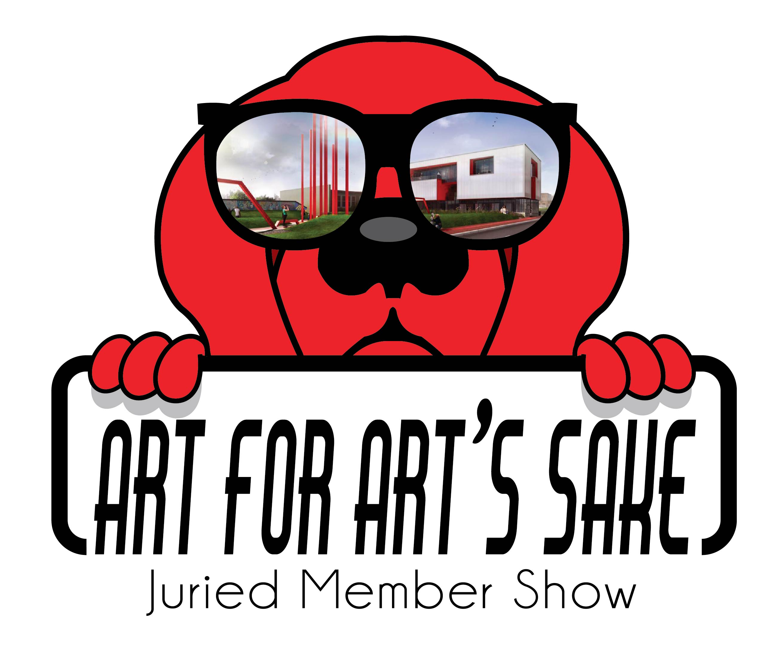
RED DOG GALLERY PRESENTS
THUMP
A Juried Exhibition Celebrating those things for which you are most Passionate.
Sponsored by Art for Art’s Sake

CALL FOR ART

This is a call for all AFAS artists to submit your latest work for THUMP. This exhibition is an opportunity to embrace those things that make your heart beat faster, put red in your cheeks and give your life meaning whether it is color, landscapes, the city, love, nature, space, sunsets, etc. whatever sets your world on fire. Up to three submissions per artist will be juried for this show. We encourage two and three-dimensional art in all mediums. Smaller art pieces are especially encouraged with a consideration to price point and size. The reception for THUMP will be held on Friday, Feb. 2, 2018 from 7 to 10 pm. The exhibit will run February 2 to March 31. We encourage all AFAS artists to share this event with friends on Facebook, Twitter and email. All artwork submitted digitally at www.theafasgroup.com. , click on Red Dog Gallery, Submissions and follow prompts. Complete steps for submission and prospectus follow:

Eligibility/Requirements
Eligibility: The exhibition is open to all AFAS artists.
Entry Deadline: Saturday, Jan. 20
Art Drop-Off: Fri., Jan. 26, 2018 (12 pm to 6 pm); Sat., 27th (11am to 4 pm)
Reception: Friday, Feb. 2, 201 8 (7 to 10 pm)
Pick up: Sat., Mar. 31, 2018 (11 am to 4 pm)

Entries: Up to 3 pieces of original artwork may be submitted on the Entry Form. Not all accepted art pieces may be exhibited at once, but hung at a designated time during the show’s duration.

All artwork submitted must be for sale.

Eligible Work:

This AFAS exhibition is to showcase outstanding visual art in two and three-dimensional art media. All 2-D and 3-D work must be “exhibition ready” upon delivery. PLEASE READ CAREFULLY WHAT EXHIBITION READY REQUIRES:

Size limitations:
- 2-D artwork – maximum size 48” x 60”
- 3-D artwork must be able to fit through a standard door and be no taller than 7 feet tall and 4 feet wide.
- 3-D artwork may weigh no more than 200 lbs.

2-D artwork must be framed and securely wired or on securely wired stretched canvas, finished on all sides. No clip mounting or saw tooth hangers will be accepted. If not adequately prepared for display, artwork will be withdrawn from the exhibition. The AFAS Group reserves the right to refuse any submission that it deems unacceptable.

Digital Submission:
Go to AFAS at www.theafasgroup.com
Click on RED DOG Gallery (at top of page)
Click on Submissions
Follow the prompts

Note: Images submitted for approval should not include the artist, as submissions are anonymous.

Be sure to submit Entry Form, Inventory Sheet, Bio and Digital Images of your artwork.

Digital Images:
ALL DIGITAL IMAGES MUST BE .JPG OR PNG FORMAT AND AT LEAST 72 DPI AND NOT MORE THAN 2MB IN SIZE.

Commission: All work available will have a commission of 35% attached as required by the AFAS Group.

ARTISTS’ CHECK LIST:
DEADLINE: Sat., Jan. 20, 2018
ENTRY FORM, INVENTORY SHEET, BIO, IMAGES
DROP OFF: Jan. 26 (12 to 6 pm), Jan. 27 (11am to 4 pm)
PLEASE TAPE LABELS TO BACK OF WORK, SIGN EXHIBITION CONTRACT
RECEPTION: FRIDAY, Feb. 2 (7 TO 10 PM) Artists attendance at this event is encouraged
PICK UP: Sat., March 31 (11 am to 4 pm)

DELIVERY/STORAGE OF ACCEPTED ART

ALL WORK SHOULD BE DELIVERED TO:
RED DOD GALLERY
630 N. LIBERTY STREET
WINSTON SALEM, NC
27101

PLEASE DELIVER AND PICK UP WORK DURING THE DESIGNATED TIMES. LATE WORK WILL NOT BE ACCEPTED. WORKS LEFT FOR MORE THAN 30 DAYS AFTER THE PICK-UP DATE BECOME THE PROPERTY OF AFAS. IF YOU HAVE SPECIAL CIRCUMSTANCES REGARDING ART DELIVERY/DROP OFF AND PICK UP/RETURN, PLEASE ADDRESS YOUR QUESTIONS TO THE AFAS WEBSITE >>RED DOG GALLERY>>Submissions>>Questions.

