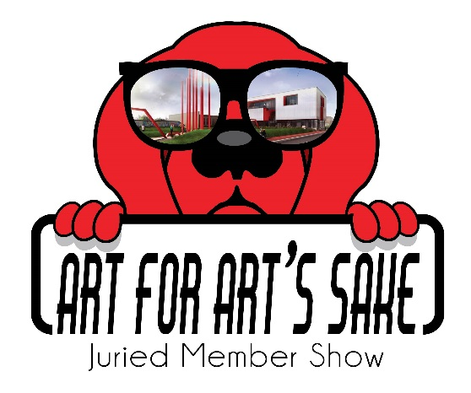
RED DOG GALLERY PRESENTS
“2024 Unbound and Unleashed”
Sponsored by Art for Art’s Sake

CALL FOR ART

Key sections to make sure you read:
- Show description and rules
- Eligibility requirements and key dates
- Size limitations and finishing
- Submitting your work online
- Delivery/Pick-up of art
- Submitting questions online

Show Description and Rules
This is a call for all AFAS artists to submit your latest work for “2024 Unbound and Unleashed” a juried exhibit at Red Dog Gallery. This is an opportunity for you to allow your inspiration from a published work of literature to inspire a work of art. This could be nonfiction, a novel, poetry, biography, comic book, essay, music, etc. At our reception attendees will also vote on a People’s Choice Award First ($100) and Second Place ($50). Voting will end at 7:30pm and the winning AFAS artists will be announced between 7:45 and 8pm at the opening reception. Make sure to have your family and friends come to opening night to vote.

For this group exhibit at The Red Dog Gallery we invite artists to submit up to 4 pieces of art that represent “2024 Unbound and Unleashed”. We are not placing a dollar limit on pricing for this show, but we are encouraging you to consider smaller pieces of art with an affordable price for our patrons as well as what the art community can bring in this area.

We are looking for two and three-dimensional art in all mediums and sizes. This includes, but not limited to, paintings, photography, pottery, jewelry, sculptures, etc. We would love to see lots of different mediums represented.

The reception for the “2024 Unbound and Unleashed” exhibit will be held on Friday, June 7, 2024 from 6 to 8 pm. The exhibit will run June 4, 2024 to August 31, 2024. We encourage all AFAS artists to invite your friends and family to the event, as well as list the event on your Facebook, Twitter, Instagram and website pages. We also have a “Shop Red Dog Gallery” page where patrons can shop the exhibit anytime from anywhere. They can email or call the gallery manager if interested in purchasing a piece. We encourage you to share this option on your social media and with friends and family.

Eligibility Requirements and Key Dates
Eligibility: The exhibition is open to all active AFAS artists.
Entry Deadline: Saturday, May 25, 2024 at midnight.
Art Drop-Off: Friday, May 31 (11 am to 6 pm); Saturday, June 1 (11 am to 4 pm). Please tape labels to the back of work and sign exhibition contract. Price must match what was submitted online.
Reception: Friday, June 7, 2023 (6 to 8 pm)
Pick up: Saturday, August 31, 2024 (11 am to 4 pm)
Entries: Up to 4 pieces of original artwork per artist may be submitted on the Entry Form and must all be submitted at the same time. All art pieces may not be exhibited at once, depending on the number of pieces accepted and space, but all work will be exhibited during the show’s duration.

All artwork submitted must be for sale.
No erotic art will be accepted for this exhibit.
Do not include your personal picture with the art submission.
Prices cannot be increased once accepted by the curators.
Must be original artwork or one-off limited prints; No mass-produced prints will be accepted.

Size Limitations and Finishing
Eligible Work:
Visual art in two and three-dimensional art media is eligible. This includes, but not limited to, paintings, photography, pottery, jewelry, sculptures, etc.
All work must be available for sale and will have a commission of 35% attached as required by the AFAS Group.
All 2-D and 3-D work must be “Exhibition Ready” upon delivery. Please read carefully what Exhibition Ready requires under the size limitations and finishing sections below:

Size limitations:
- 2-D artwork – maximum size 48” width x 60” height
- 3-D artwork must be able to fit through a standard door and be no taller than 7 feet tall and 4 feet wide.
- 3-D artwork may weigh no more than 200 lbs.

Finishing:
- 2-D artwork must be framed and securely wired or on securely wired stretched canvas, finished on all sides (painted or framed).
- No clip mounting or saw tooth hangers will be accepted.
- If not adequately prepared for display, artwork will be withdrawn from the exhibition. The AFAS Group reserves the right to refuse any submission that it deems unacceptable.

Submitting Your Work Online
All artwork must be submitted digitally at www.theafasgroup.com, all artwork must be submitted at the same time.

Go to AFAS at www.theafasgroup.com
Click on RED DOG Gallery (at top of page)
Click on Submissions
Follow the prompts for “2024 Unleashed and Unbound”

Bio Files:
Must be less than 2MB in file size and the file name must not contain any of the special characters listed below – letters and numbers only please:
~ ' ! @ # $ % ^ & * ( ) + [ ] \ ; , / { } | \ : < > ?
Digital Images:
All digital images must be .jpg or .png format, at least 72 dpi, less than 2MB in file size and the image file name must not contain any of the special characters listed below– letters and numbers only please:
~ ' ! @ # $ % ^ & * ( ) + [ ] \ ; , / { } | \ : < > ?
Note: Images submitted for approval should not include the artist in the image, as submissions are anonymous.

Delivery/Pick-up of Accepted Art
All work should be delivered on the designated dates/times to:
Red Dog Gallery
630 N. Liberty Street
Winston-Salem, NC
27101

Late work will not be accepted.
Works left for more than 30 days after the pick-up date become the property of AFAS. If you have special circumstances regarding art delivery / drop off / pick up/ return/ or other exhibit questions, please enter questions to the curators on the AFAS website at
Red Dog Gallery>>Submissions>>Questions.

